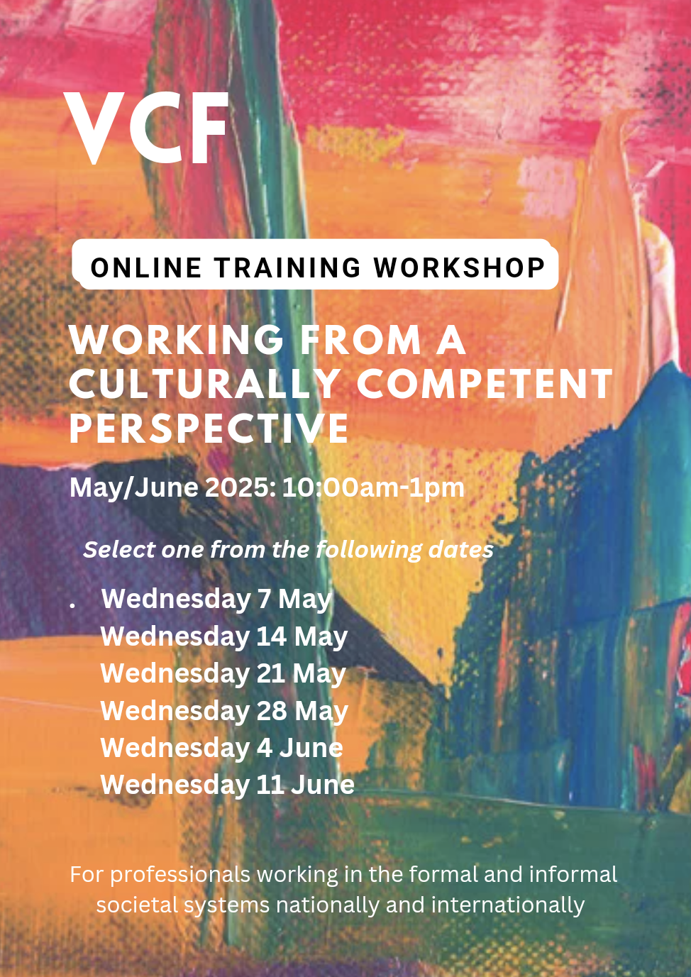

**Introduction to the Training Workshop**

**‘Working from a culturally competent perspective’** is one of a series of training workshops for professionals working in the formal and informal societal systems nationally and internationally; to understand what working from a culturally competent viewpoint is about. The necessity of it and ways to begin the cultural competency journey. What happens when we don't consider culture. To articulate your own definition and understanding of cultural competence. The relevant knowledge base when working with children and families, particularly Black African families. Delegates will explore the impact of their own self-concept on their work/intervention with Black children and families from a culturally competent perspective.

**Note**: It is recommended that this workshop is a pre-requisite for all other courses in this series.

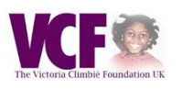

**VCF - The Victoria Climbié Foundation UK**

🟪 Established by Mr & Mrs Climbié following the public inquiry into child protection

🟪 Advocate for improvements in child protection policies and practices

🟪 Link organisation between statutory agencies, care services and communities

🟪 VCF is the leading independent organisation addressing children's rights to care and protection across all ethnicities.

Email: [victoriaclimbiefoundationuk@gmail.com](mailto:victoriaclimbiefoundationuk@gmail.com)

**Amma Anane-Agyei - Workshop Facilitator**

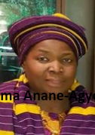

🟨 Founder, New African Families Service National and International Network (NAFSNIN)

🟨 Lifetime Achievement Award Winner; KeolisAmey Docklands Community Champion Award

🟨 European Consortium Member; Italy, France, Spain, Belgium and Romania

🟨 Qualified Social Worker, Trainer, Consultant, Registered Expert Witness Assessor

🟨 Awarded Honorary Doctorate of Letters from the University of West London (2024)

Email: [nafsnin@outlook.com](mailto:nafsnin@outlook.com)



**Registration**

Please book for your training workshop by completing and returning this form (or a scanned copy) to VCF via email: [victoriaclimbiefoundationuk@gmail.com](mailto:victoriaclimbiefoundationuk@gmail.com)

Full Name:

Email:

Phone Number:

Organisation (if applicable):

**Workshop Dates**

Select one from the following;

Wednesday 7 May 2025

Wednesday 14 May 2025

Wednesday 21 May 2025

Wednesday 28 May 2025

Wednesday 4 June 2025

Wednesday 11 June 2025

**PRODUCT/SERVICE**

Working from a Culturally Competent Perspective / Online Training Workshop (3 hours) – Zoom

£45.00

**PAYMENT**

Payments should be lodged directly to:

The Victoria Climbié Foundation UK

Camden Branch

Sort Code: 40-02-03

Account Number: 01508040

**ADDITIONAL INFORMATION**

Please indicate your interest in any of the following, for priority booking on future workshops

Child Abuse Linked to Faith or Belief

Culturally appropriate Parenting

Female Genital Mutilation (FGM)

Safeguarding issues

Working from a Culturally Competent Perspective